Task 2.1
unlogged files skip WAL loggings, which are important for D in ACID, durability against accidents.
Skipping WAL loggings significantly speeds up the inserting.
It took more than 7 seconds for logged table to insert 5 mil rows and just around 1 second for the unlogged table.
--Planning Time: 0.090 ms
--Execution Time: 7879.475 ms
--Planning Time: 0.058 ms
--Execution Time: 1233.028 ms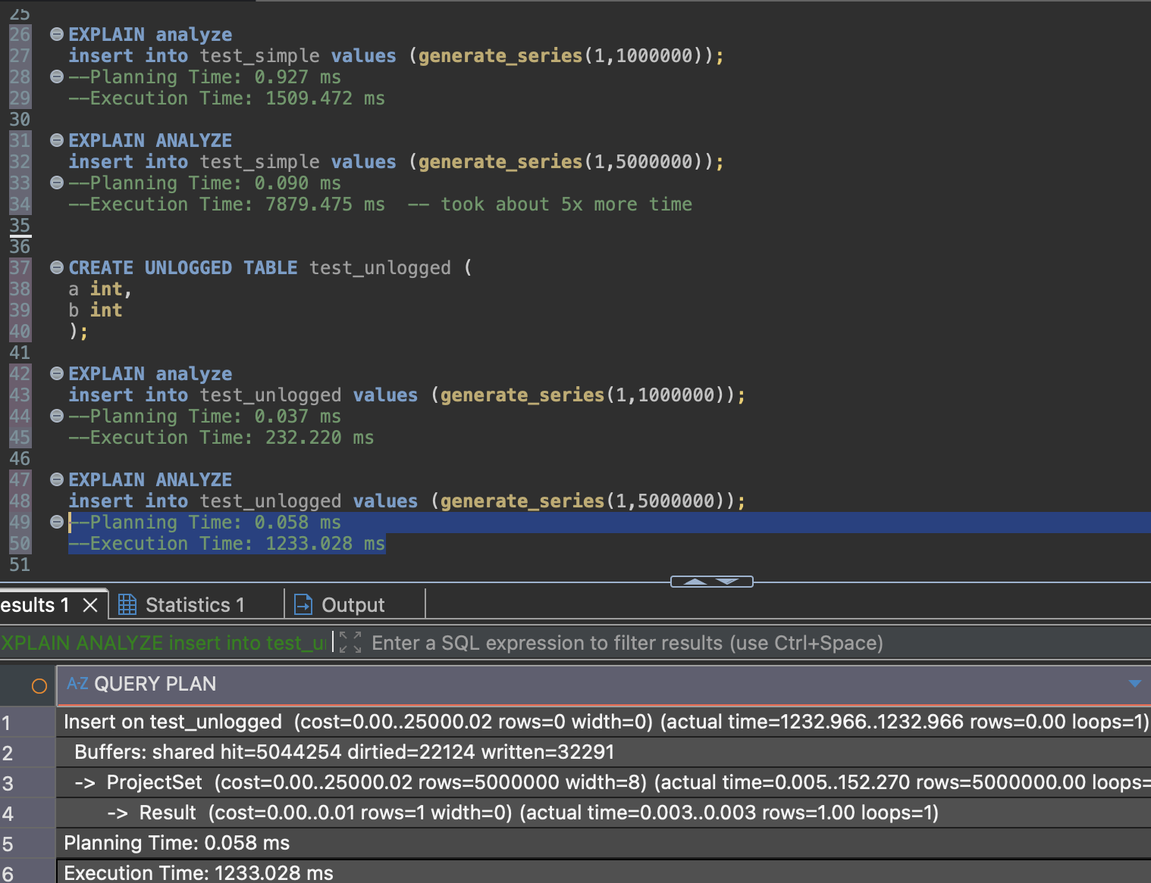

Task 2.2
Inserting values into inherited tables also adds those values to the parent tables. Child tables have their own and parent columns, so it becomes more important for clarity and accuracy to specifically select which columns are the values being inserted into.
ONLY keyword can be used to disregard data from child tables.
Updating parent table updates child table too. Updating with ‘Only’ keyword leaves the child table unchanged.
Altering parent table alters child table too. Whether adding columns or creating constraints NO INHERIT can contain the change only to the parent table.
However, even if applying uniqueness constraint without NO INHERIT, global uniqueness between parent and child tables combined won’t be enforced.

Task 3.1
By running the select statement on unidexed table all the rows are read and assessed whether they satisfy the where condition.
-> Parallel Seq Scan on test_index
Rows Removed by Filter: 5084640
The whole process took around half a second.
Execution Time: 528.370 ms

Indexed table takes almost half the time to complete, the process is different.
Execution Time: 211.491 ms

Index creation ~7 seconds.
index size 333MB
table size 666MB
total size 1004MB
BRIN index took ~half second to create.
Execution Time: 182.101 ms – even less than with regular index.
Size of the brin index is just 40KB.
The way BRIN index works is suitable for some of the tables. The consecutive timestamps table is suitable for BRIN as it sorts data in block ranges. It’s approximate, finds blocks it needs and goes through the blocks themselves without indexing.

Task 3.2
It took half a second to find a specific value on a table with ids and hashes.
Plannig Time: 0.098 ms
Execution Time: 550.160 ms

Gist indexing took 4 minute 22 seconds
Gin indexing took 1 minute. Index size 600MB
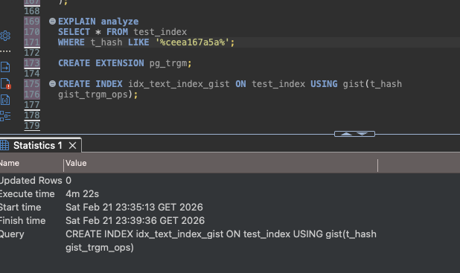
Select statement execution time:
Plain: 550.160 ms
Gist: 13,602.923 ms
Gin: 44.188 ms
The indexes are suitable for various datasets. Gin is widely used for text searches, arrays, JSONs. It easily searches the trigrams – the 3-character breakdowns of rows. Looks for each of those 3-character pieces when searching with ‘like’ then finds the interesctions.
Gist is approximates the values in rows and requires extra check by a database. It’s suitable for other types of data, like geospacial.
Task 4.1
CREATE EXTENSION file_fdw; loads foreign data wrapper functionality
CREATE SERVER test_import FOREIGN DATA WRAPPER file_fdw; creates space where the foreign data will be placed.
The placement of the foreign data source must be accessible to PostgreSQL.
The foreign table and the materialized view made from it had the same count of rows.
Removing some rows from source csv immediately was reflected in FDW, however not in materialized view.
Unlike a regular view, materialized view table takes snapshots of information, so to update it REFRESH MATERIALIZED VIEW was required to reflect deletion of the rows.

